***Virginia Junior Classical League***

*presents this*

Certificate of Excellence

*to*

Denise Davies

*of*

Clover Hill High School

*for*

*1st Place in Ornaments*

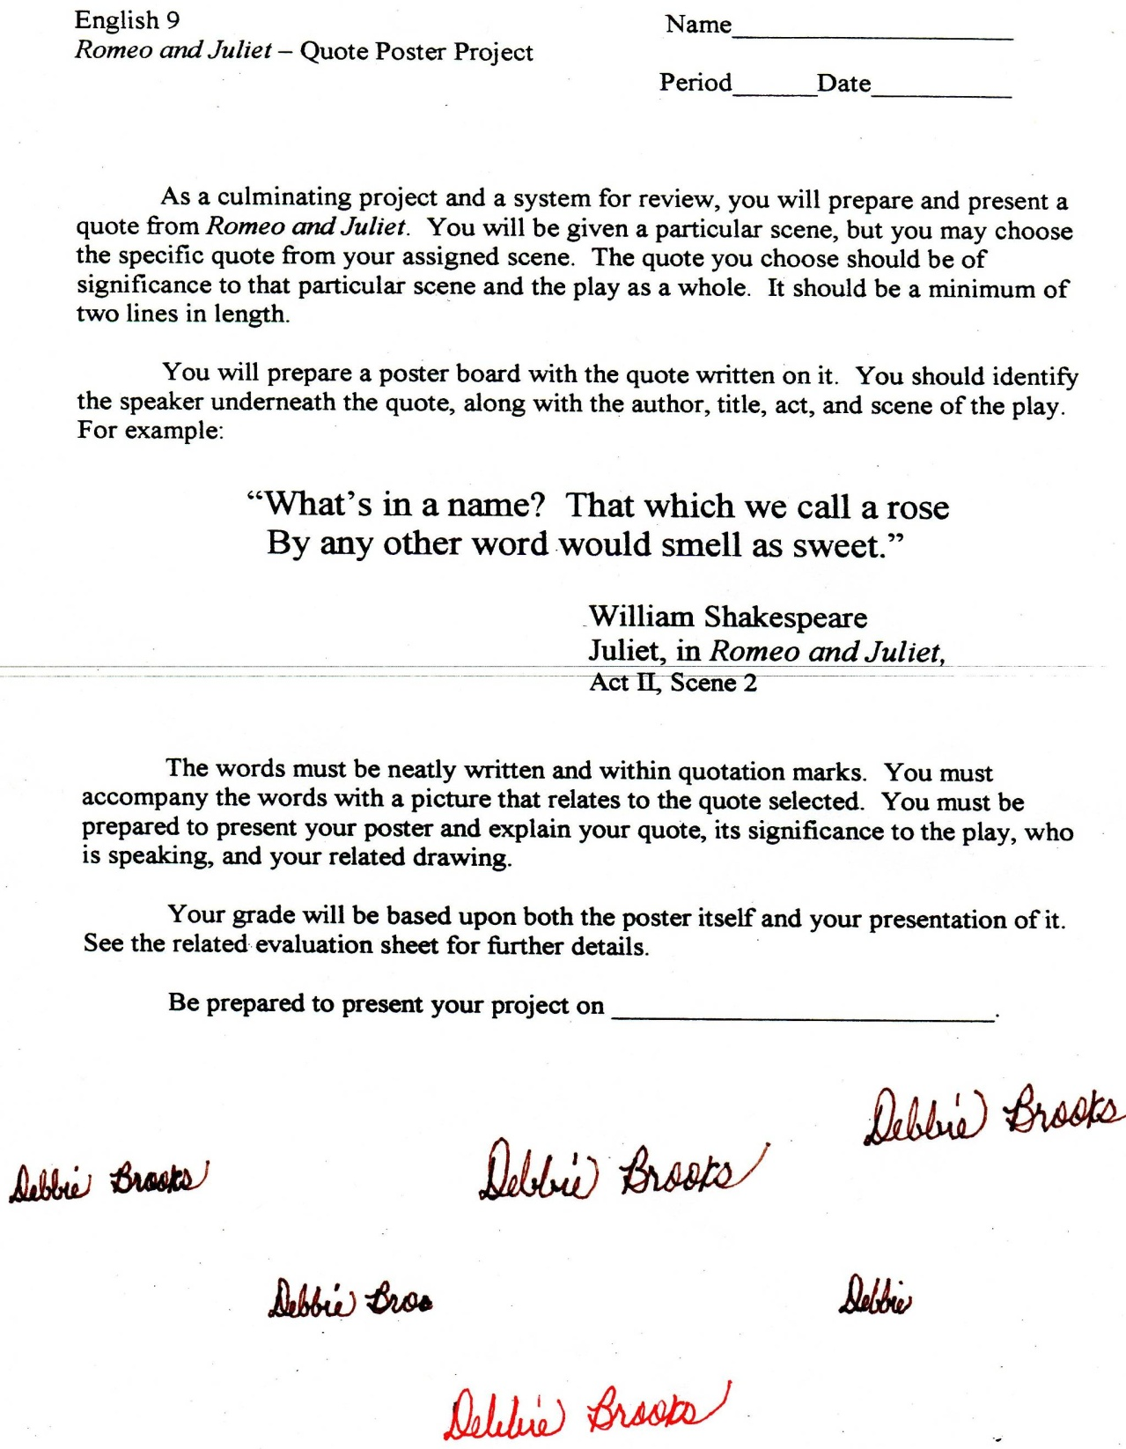

Microsoft Office Signature Line...

*a.d. viii Kal. Dec. MMDCCLXVII A.U.C. 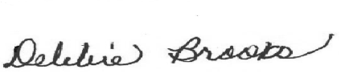*

***Virginia Junior Classical League***

*presents this*

Certificate of Excellence

*to*

Morgan Necessary

*of*

Clover Hill High School

*for*

*1st Place in Posters*

**

Microsoft Office Signature Line...

*a.d. viii Kal. Dec. MMDCCLXVII A.U.C. *

***Virginia Junior Classical League***

*presents this*

Certificate of Excellence

*to*

Erica Taylor

*of*

Clover Hill High School

*for*

*1st Place in Oil*

**

Microsoft Office Signature Line...

*a.d. viii Kal. Dec. MMDCCLXVII A.U.C. *

***Virginia Junior Classical League***

*presents this*

Certificate of Excellence

*to*

Noor Rafiq

*of*

Clover Hill High School

*for*

*4th Place in Jewelry*

**

Microsoft Office Signature Line...

*a.d. viii Kal. Dec. MMDCCLXVII A.U.C. *

***Virginia Junior Classical League***

*presents this*

Certificate of Excellence

*to*

Maggie Damico

*of*

Clover Hill High School

*for*

*4th Place in Other*

**

Microsoft Office Signature Line...

*a.d. viii Kal. Dec. MMDCCLXVII A.U.C. *

***Virginia Junior Classical League***

*presents this*

Certificate of Excellence

*to*

Jack Morris

*of*

Clover Hill High School

*for*

*4th Place in Photography - Group*

**

Microsoft Office Signature Line...

*a.d. viii Kal. Dec. MMDCCLXVII A.U.C. *

***Virginia Junior Classical League***

*presents this*

Certificate of Excellence

*to*

Erica Taylor

*of*

Clover Hill High School

*for*

*5th Place in Other*

**

Microsoft Office Signature Line...

*a.d. viii Kal. Dec. MMDCCLXVII A.U.C. *

***Virginia Junior Classical League***

*presents this*

Certificate of Excellence

*to*

Noor Rafiq

*of*

Clover Hill High School

*for*

*5th Place in Oil*

**

Microsoft Office Signature Line...

*a.d. viii Kal. Dec. MMDCCLXVII A.U.C. *

***Virginia Junior Classical League***

*presents this*

Certificate of Excellence

*to*

Jake ten Kate

*of*

Clover Hill High School

*for*

*6th Place in Costume - Boys Upper Division*

**

Microsoft Office Signature Line...

*a.d. viii Kal. Dec. MMDCCLXVII A.U.C. *

***Virginia Junior Classical League***

*presents this*

Certificate of Excellence

*to*

Morgan Necessary

*of*

Clover Hill High School

*for*

*7th Place in Maps*

**

Microsoft Office Signature Line...

*a.d. viii Kal. Dec. MMDCCLXVII A.U.C. *

***Virginia Junior Classical League***

*presents this*

Certificate of Excellence

*to*

Jack Morris

*of*

Clover Hill High School

*for*

*8th Place in Geography*

**

Microsoft Office Signature Line...

*a.d. viii Kal. Dec. MMDCCLXVII A.U.C. *

***Virginia Junior Classical League***

*presents this*

Certificate of Excellence

*to*

Robbie Taranto

*of*

Clover Hill High School

*for*

*8th Place in Mythology*

**

Microsoft Office Signature Line...

*a.d. viii Kal. Dec. MMDCCLXVII A.U.C. *

***Virginia Junior Classical League***

*presents this*

Certificate of Excellence

*to*

Maggie Damico

*of*

Clover Hill High School

*for*

*9th Place in Watercolor*

**

Microsoft Office Signature Line...

*a.d. viii Kal. Dec. MMDCCLXVII A.U.C. *

***Virginia Junior Classical League***

*presents this*

Certificate of Excellence

*to*

Mary O'Reilly

*of*

Clover Hill High School

*for*

*10th Place in Life*

**

Microsoft Office Signature Line...

*a.d. viii Kal. Dec. MMDCCLXVII A.U.C. *

***Virginia Junior Classical League***

*presents this*

Certificate of Excellence

*to*

Alexis Dorneman

*of*

Clover Hill High School

*for*

*10th Place in Life*

**

Microsoft Office Signature Line...

*a.d. viii Kal. Dec. MMDCCLXVII A.U.C. *